Name & Student ID
Frank Wainwright s20466079

Title
Writing Robot Software Project System Manual

Software Description
The Writing Robot Program initialises communication with the robot by opening the appropriate port and sends instructions to wake up the robot. If this succeeds it asks the user to input a height in mm for their text, then processes text to be written from one file, and the font to use from a second file. This font is then adjusted by the scale the user specified. Following this words are parsed out from the text and GCode is generated for them using the font information. The GCode commands are generated such that they ensure that text does not cross the maximum width and whole words are not broken up. These commands are then sent to the robot. Once all words in the text have been processed a GCode command is sent to send the robot back to the origin and the communication port is closed while the program ends.
Sample emulator output:
Font size 8:
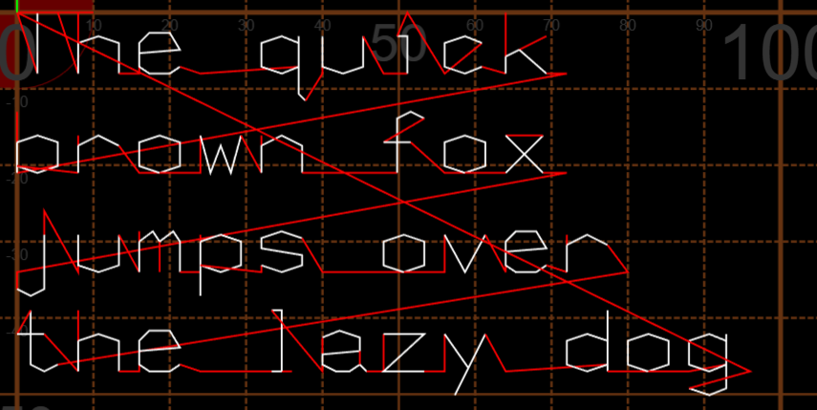
Font size 6:
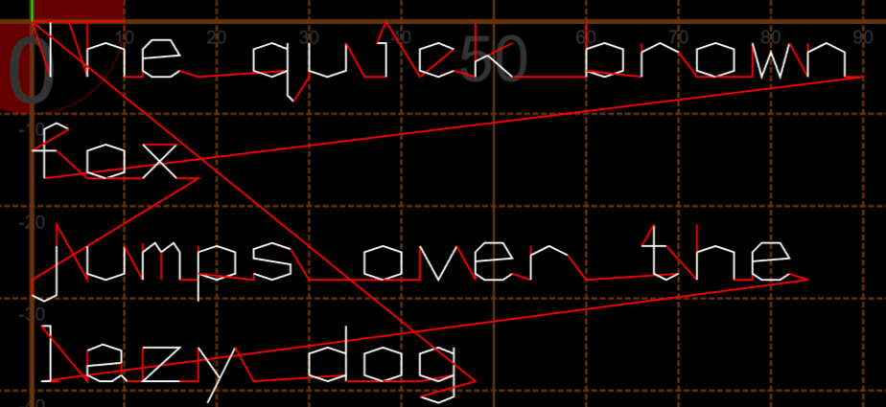
Test.txt includes a line break after “fox”

Project Files
Main.c
Main program body that calls other functions and has word processing / command generation loop
RobotInit.h
Header file linking RobotInit.c to Main.c
RobotInit.c
File that contains functions that ask user for font input and reads font file
RobotCommand.h
Header file linking RobotCommand.c to Main.c
RobotCommand.c
File that contains functions that read words from the text, translate them into GCode commands with correct formatting and then send them.
rs232.h
Header file linking rs232.c to Main.c, RobotCommand.c and serial.c
rs232.c
File that contains functions that open ports and enable communication to the robot
serial.h
Header file linking serial.c to Main.c and RobotCommands.c
serial.c
File that contains functions that handle communication to the robot

Key Data Items
Name | Data type | Rationale
FontHeight | Int | Simple integer of user input height between 4 and 10
FontData | Struct (Formatted Integers) | Formatted integers from header of character definition (Character ascii value, number of instructions), and struct of Instructions
Instructions | Struct (Formatted Integers) | Formatted integers from font file (X movement, Y movement, Pen state)
WordLength | Int | Integer number of items in array
XOffset | Double | Store offsets in x direction to respect new lines, is divided and multiplied and may have decimals
YOffset | Double | Store offsets in y direction to respect new lines, is divided and multiplied and may have decimals
NextWord | Int Array | Array of ascii values representing a word until the next space (ascii value 32)
buffer | char | Formatted instructions ready to be sent

Functions
int FontRead(const char *fontfilename, unsigned int FontHeight)
Opens font file and reads data from it into the FontData structure with instructions modified by FontHeight
Parameters:
fontfilename – Name of the font file to be opened
FontHeight - Height user specified for font
FontSet(Pointer) – Array of structures
Return value – Returns 1 for success, 0 for failure
int Initialisation(const char *FontFileName)
Requests user to input a font height and then calls FontRead passing the font height to it
Parameters:
FontFileName – Name of the font file to be opened
FontHeight(Created) – Height of font user inputs
Return value – Returns 1 for success, exits program if FontRead returns 0
int TextReadWord(const char *TextFileName, FILE **TextFile, int *NextWord, int *WordLength, unsigned int *TrailingSpaces)
Opens Text file and parses one word from it, taking count of spaces trailing a word and handles linebreaks
Parameters:
TextFileName – Name of the text file to be opened
TextFile – Pointer back to file after the stream has been opened
NextWord– Array of ascii values comprising the next parsed word to be sent
WordLength – Length of the word that was just parsed
TrailingSpaces – Number of spaces that follow after the text
Return value – Returns 1 for success/ new word, Returns 0 for no new word, Exits program when failure to read
int GenerateGCode(int *NextWord, int WordLength, unsigned int TrailingSpaces)
Generates commands for each letter in the word using information from the FontData structure
Parameters:
NextWord– Array of ascii values comprising the next parsed word to be sent
WordLength – Length of the word that was just parsed
TrailingSpaces – Number of spaces that follow after the text
FontSet(Pointer) – Array of structures containing information on font
Return value – Returns 1 for success, Exits program for failure

Testing Information
Function | Test Case | Test Data | Expected Output
Main | Correct Inputs | Text.txt SingleStrokeFont.txt | All functions return 1 until text is finished and the writing robot writes all of the text.
Initialisation | Correct Inputs | SingleStrokeFont.txt, User input between 4-10 | All font information is saved to the FontData array with the correct height and outputs 1
Initialisation | Incorrect height | SingleStrokeFont.txt, User input NOT between 4-8 or not integer | Ask the user for input again within correct range
FontRead | Incorrect filename or no file | SingleStrokeFont.txt missing or incorrect fontfilename to assign pointer to it | Outputs 0,program closes (Initialisation function)
TextReadWord | Incorrect filename or no file | Text.txt missing or incorrect textfilename to assign pointer to it | Exits program
TextReadWord | Correct Inputs first run | TextInput (ascii values of Hello World) | 72 101 108 108 111 32 in NextWord  Outputs 1
TextParse | Correct Inputs second run | TextInput (ascii values of Hello World) | 87 111 114 108 100 in NextWord  Outputs 1
TextReadWord | No Inputs or no values left | Invalid TextInput or no array data left | Outputs 0
GenerateGCode | Correct Inputs | NextWord (ascii values of Hello), FontData | GCode of each letter in ‘Hello’ with correct offset horizontally  Outputs 1
GenerateGCode | Correct Inputs, new line required | NextWord (ascii values of World), FontData | GCode of each letter in ‘World’ with correct offset vertically and horizontally  Outputs 1
GenerateGCode | Incorrect inputs | Ascii value in NextWord array with no matching font data | Return 0, program ends normally

AI Statement
No AI was used in the creation of this System Manual nor the Robot Writer code.

Flowchart(s)
